Mini Project: Project Ideation

Name: Syukur Sidiq Nur Alam Cohort: BDSE07-UIF

1. Understand the overview of the Community Portal from Project Mentor.

|  |  |  |
| --- | --- | --- |
| No | Questions | Answers |
| 1 | This application resembles LinkedIn, what about features, is it complete? | That’s right we have considered for the feature features are not much different and we have also made a subscription fee that can be affordable for everyone. |
| 2 | What does the user fill in information such as skills for, do you intend to open a job vacancy? | We want to make it easier for visitors to get a job and for the company as well so that they can quickly get employees. |
| 4 | what about his subscription fee is it better than other apps? | Every year, for one week, we offer users a free subscription, and the cost is kept low so that everyone can use it. |
| 5 | Is the website simple for visitors to understand? | We created this website  is so simple that the user will not be confused when trying to see something. |
| 6 | This application is specialized in sending what kind of content? Is it just a place to find a job | We also have an online learning feature for the content so that users can exchange knowledge with one another in addition to job searching |

1. Persona

List the different personas who will be using the Community Portal, with brief description of each of the personas.

|  |  |  |
| --- | --- | --- |
| No | Persona | Brief Description |
| 1 | Udin petot | Udin is looking for additional jobs that match his skills |
| 2 | Mahmud slebew | Mahmud wants to know about the information of IT companies. |
|  | Siti anjay | Siti is a female student and she also works as an IT freelance |
|  | Roger sumatera | Roger wants to join some groups discussion for her study |

1. Create a Personas profile with Demographics, Behaviors & Beliefs, Characteristics & Goals for 2 Personas defined.

|  |  |
| --- | --- |
| Persona (1): | Alex |
| Demographics: | 22, Male, Freelance programmer |
| Behaviors and Beliefs: | Like discussion, smart work and do not like to waste time |
| Characteristics: | Thinker |
| Goals: | To make it easier to get a job |

|  |  |
| --- | --- |
| Persona (2): | Bayu |
| Demographics: | 20, Male, programmer Junior |
| Behaviors and Beliefs: | Always looking to find out, Calm |
| Characteristics: | Thinker |
| Goals: | To become an expert programmer |

1. Conduct Ideation for the Project Scenario and come up with 2 Ideas to meet the Project Scenario

Scenario Name: looking for people to follow

|  |  |
| --- | --- |
| No | Ideas |
| 1 | Dudun wanted to add followers so he went to the my network button and looked for people for him to follow |
| 2 | Dudun wants to increase followers. So he went to the profile and on the right side there was a tab that said " People you may Know" then dudun chose the person he would follow |

1. Create Scenario & Storyboard for one of the Scenarios

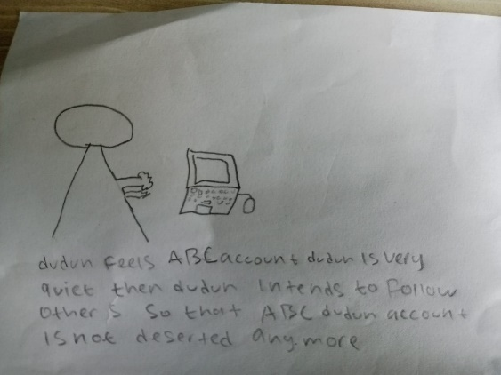

dudun feels ABC account dudun is very quiet then dudun intends to follow others so that ABC dudun account is not deserted anymore

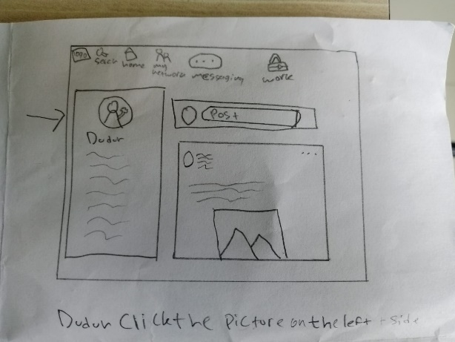

Dudun click the picture on the left side

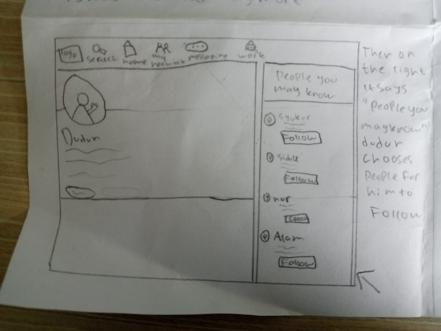

Then on the right it says "people you may know" dudun chooses people for him to follow

1. Use Axure to Create a Wireframe Prototype for 1 Scenario Scenario Name: looking for people to follow

|  |  |
| --- | --- |
| Wireframe pages | Specifications (Widget Table) |
|  | |  |  |  | | --- | --- | --- | | Note No. | Name | Note | | 1 | Company Logo | Logo of ABC Jobs Pte. Ltd. | | 2 | Search | To find people | | 3 | Home | Navigation to the home page | | 4 | My Network | Navigation to the My Network page See friends | | 5 | Message | Navigation to the Message page to chat | | 6 | Work | Navigation to the Work page to find a job | | 7 | Post | To share your story | | 8 | Logo profile | Navigation to the Profile page | | 9 | Content Picture | Results of Story Posts | | 10 | Edit | To change personal data | | 11 | cover photo | second photo of the profile | | 12 | Follow | button to follow people | |
|  |  |

7. Plan the Implementation for the Project Scenario

|  |  |
| --- | --- |
| Priorities | Scenario |
| Top | 1. Community Portal Home Page  2. Registration Page  3. Registration Confirmation Page  4. Update the Profile Page  5. Search Users Page  6. List Search Results  8. Registration Confirmation Email  9. Login Page  10. Forget Password Page  11.My Network page  12. Message Page  13. Work Page  14. Design the Forget Password Confirmation Page |